# Lab: Complex Conditional Statements

Test your tasks in the Judge system: [https://judge.softuni.org/Contests/4398](https://judge.softuni.org/Contests/4398 )

## Marketplace

Write a program that:

* Reads **two strings** from the console: **product** (string) and **day** (string).
* Print the price, formatted to the **second digit**, based on the price table:

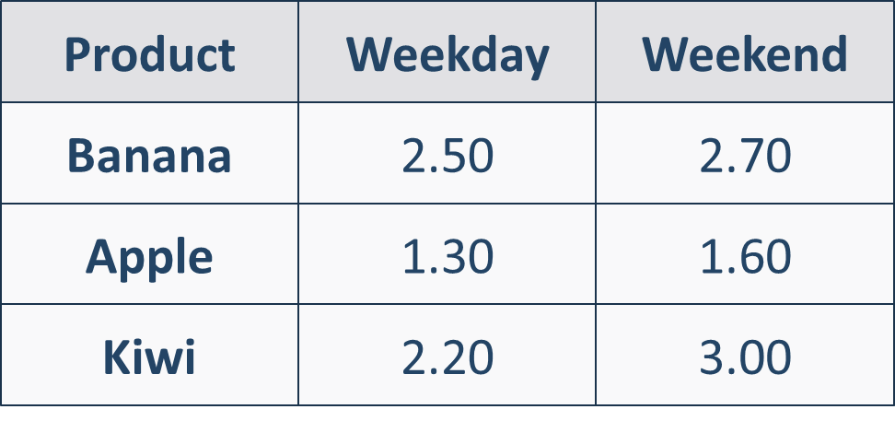

### Example

|  |  |  |  |  |  |  |  |
| --- | --- | --- | --- | --- | --- | --- | --- |
| **Input** | **Output** |  | **Input** | **Output** |  | **Input** | **Output** |
| Kiwi  Weekday | 2.20 | Banana  Weekend | 2.70 | Apple  Weekend | 1.60 |

### Guidelines

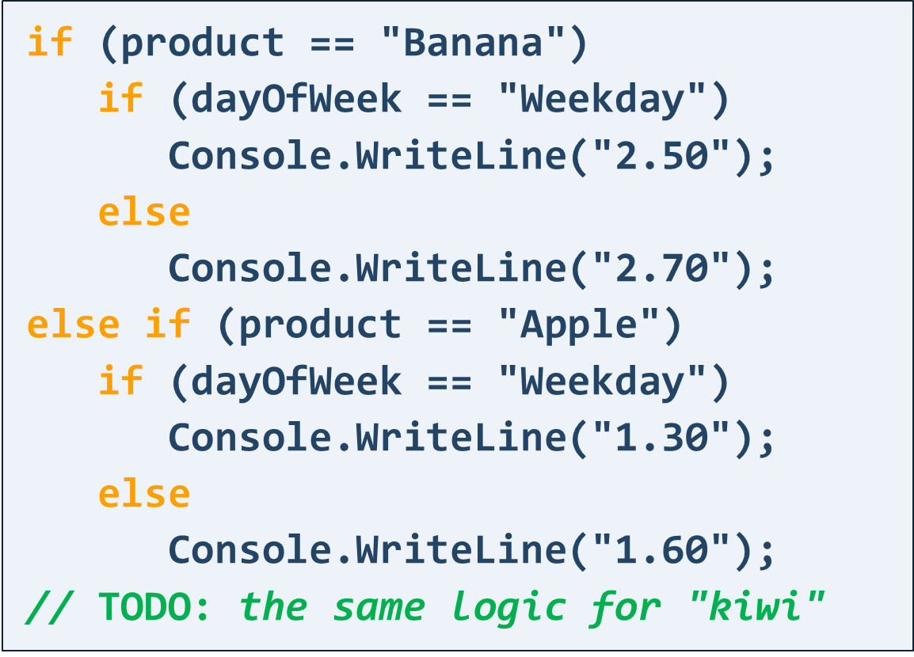

string product = (Console.ReadLine());

string dayOfweek = (Console.ReadLine());

if (product == "Kiwi")

{

if (dayOfweek == "Weekday")

Console.WriteLine("2.20");

else

{

Console.WriteLine("3.00");

}

}

else if (product == "Apple")

{

if (dayOfweek == "Weekday")

Console.WriteLine("1.30");

else

{

Console.WriteLine("1.60");

}

}

else if (product == "Banana")

{

if (dayOfweek == "Weekday")

Console.WriteLine("2.50");

else

{

Console.WriteLine("2.70");

}

}

## Largest Number Out of Three

Write a program that:

* Reads **3 integer numbers** from the console
* Prints **the largest number**

**int first =int.Parse(Console.ReadLine());**

int second =int.Parse(Console.ReadLine());

int third =int.Parse(Console.ReadLine());

if (first > second && first > third)

Console.WriteLine($"{first}");

else if (second > third && second > first) Console.WriteLine($"{second}");

else

Console.WriteLine($"{third}");

|  |  |  |  |  |  |  |  |
| --- | --- | --- | --- | --- | --- | --- | --- |
| **Input** | **Output** |  | **Input** | **Output** |  | **Input** | **Output** |
| 1  2  3 | 3 | -1  -5  -9 | -1 | 6  9  10 | 10 |

### Guidelines

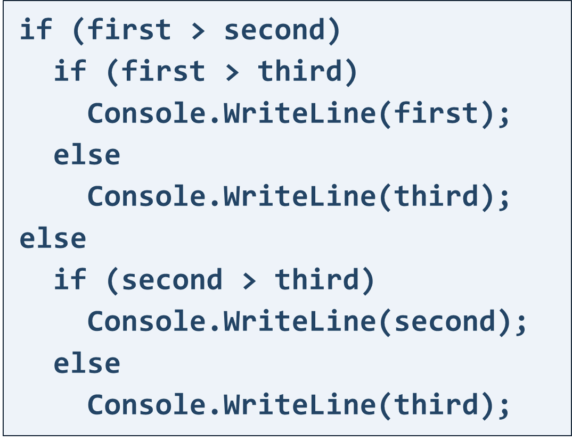

## Bonus Score

Write a program that:

* Reads **points (integer number)** from the console
* Add **bonus points to given points** based on following:
  + If points are **between 0 and 3 (inclusive)**, adds 5 to the given points
  + If points are **between 4 and 6** **(inclusive)**, adds 15 to the given points
  + If points are **between 7 and 9** **(inclusive)**, adds 20 to the given points
* Print final points after adding the bonus points

int number = int.Parse(Console.ReadLine());

if (number <= 3)

{

int bonus5 = number + 5;

Console.WriteLine($"{bonus5}");

}

else if (number >= 4 && number <= 6)

{

int bonus15 = number + 15;

Console.WriteLine($"{bonus15}");

}

else if (number >= 7 && number <= 9)

{

int bonus20 = number + 20;

Console.WriteLine($"{bonus20}");

}

### Example

|  |  |  |
| --- | --- | --- |
| **Input** | **Output** | **Comments** |
| **1** | 6 | The given points are with value: **1**  This value is **between 0 and 3**, so we add **5** points to the given points:  **1** + **5** = 6 |
| **4** | 19 | The given points are with value: **4**  This value is **between 4 and 6**, so we add **15** points to the given points:  **4** + **15** = 19 |

## Food or Drink

Write a program that:

* Reads a **product (string)** from the console
* Based on type of the given product, print:
  + If product is one of following "**curry"**, "**noodles"**, "**sushi"**, "**spaghetti"** or "**bread"** you have to print **"food"**
  + If product is one of following "**tea"**, "**water"**, "**coffee"** or "**juice"** you have to print **"drink"**
  + If the product is different from listed products above, print **"unknown"**

string product = Console.ReadLine();

if (product == "curry" || product == "noodles" || product == "sushi" || product == "spaghetti" || product == "bread")

{

Console.WriteLine("food");

}

else if (product == "tea" || product == "water" || product == "coffee" || product == "juice")

{

Console.WriteLine("drink");

}

else

{

Console.WriteLine("unknown");

}

### Example

|  |  |  |  |  |  |  |  |
| --- | --- | --- | --- | --- | --- | --- | --- |
| **Input** | **Output** |  | **Input** | **Output** |  | **Input** | **Output** |
| sushi | food | water | drink | car | unknown |

## Invalid Number

A given number is **valid** if it is in **the range [100...200]** or it is **equals to 0**.

Write a program that:

* Reads an integer from the console
* Prints "**invalid**" if the entered number is **NOT** valid

**int number = int.Parse(Console.ReadLine());**

**if (number == 0 || number >= 100 && number <= 200)**

**{**

**Console.WriteLine("");**

**}**

**else**

**{**

**Console.WriteLine("invalid");**

**}**

### Example

|  |  |  |  |  |  |  |  |
| --- | --- | --- | --- | --- | --- | --- | --- |
| **Input** | **Output** |  | **Input** | **Output** |  | **Input** | **Output** |
| 75 | invalid | 150 | *(няма изход)* | 0 | *(няма изход)* |

## Day of Week

Write a program to **print the day of week as words**, which:

* Reads **an integer number** (the number will be in range [1… 7]) from the console
* Based on the value of the number, print:
  + If the given number is equals to **1** print the first day of the week, which is "**Monday**"
  + If the given number is equals to **2** print the second day of the week, which is "**Tuesday**"
  + If the given number is equals to **3** print the third day of the week, which is "**Wednesday**"
  + If the given number is equals to **4** print the fourth day of the week, which is "**Thursday**"
  + If the given number is equals to **5** print the fifth day of the week, which is "**Friday**"
  + If the given number is equals to **6** print the sixth day of the week, which is "**Saturday**"
  + If the given number is equals to **7** print the seventh day of the week, which is "**Sunday**"
  + If the given number **is out of the given range** print "**Error**"

**int dayNumber = int.Parse(Console.ReadLine()); if (dayNumber == 1) { Console.WriteLine("Monday"); } else if (dayNumber == 2) { Console.WriteLine("Tuesday"); } else if (dayNumber == 3) { Console.WriteLine("Wednesday"); } else if (dayNumber == 4) { Console.WriteLine("Thursday"); } else if (dayNumber == 5) { Console.WriteLine("Friday"); } else if (dayNumber == 6) { Console.WriteLine("Saturday"); } else if (dayNumber == 7) { Console.WriteLine("Sunday"); } else { Console.WriteLine("Error"); } } }**

### Example

|  |  |  |  |  |  |  |  |
| --- | --- | --- | --- | --- | --- | --- | --- |
| **Input** | **Output** |  | **Input** | **Output** |  | **Input** | **Output** |
| 1 | Monday | 2 | Tuesday | 3 | Wednesday |

|  |  |  |  |  |  |  |  |
| --- | --- | --- | --- | --- | --- | --- | --- |
| **Input** | **Output** |  | **Input** | **Output** |  | **Input** | **Output** |
| 4 | Thursday | 5 | Friday | 6 | Saturday |

|  |  |  |  |  |  |  |  |
| --- | --- | --- | --- | --- | --- | --- | --- |
| **Input** | **Output** |  | **Input** | **Output** |  | **Input** | **Output** |
| 7 | Sunday | 10 | Error | -8 | Error |

## Vowel or Consonant

Write a program to **check a letter for vowel or consonant**:

* Reads a **character (letter, part of the English alphabet)** from the console
* Based on the value of the character, print:
  + If the character is **vowel letter** print "**Vowel**"

**Hint:** Vowels letters are: **A, a, E, e, I, i, O, o, U, u**

* + If the character is **consonant letter** print "**Consonant**"

**char letter = char.Parse(Console.ReadLine());**

if (letter == 'A' || letter == 'a' ||

letter == 'E' || letter == 'e' ||

letter == 'I' || letter == 'i' ||

letter == 'O' || letter == 'o' ||

letter == 'U' || letter == 'u')

{

Console.WriteLine("Vowel");

}

else

{

Console.WriteLine("Consonant");

}

### Example

|  |  |  |  |  |  |  |  |
| --- | --- | --- | --- | --- | --- | --- | --- |
| **Input** | **Output** |  | **Input** | **Output** |  | **Input** | **Output** |
| a | Vowel | A | Vowel | E | Vowel |

|  |  |  |  |  |  |  |  |
| --- | --- | --- | --- | --- | --- | --- | --- |
| **Input** | **Output** |  | **Input** | **Output** |  | **Input** | **Output** |
| e | Vowel | O | Vowel | d | Consonant |

|  |  |  |  |  |  |  |  |
| --- | --- | --- | --- | --- | --- | --- | --- |
| **Input** | **Output** |  | **Input** | **Output** |  | **Input** | **Output** |
| o | Vowel | U | Vowel | R | Consonant |

## Sorted Numbers

Write a program, which checks for **sorted 3 numbers**:

* Reads **3 integer numbers** from the console
* Based on the order of the numbers, print:
  + **"Ascending"** – if the numbers are in ascending order (from the smallest to the largest number)
  + **"Descending"** – if the numbers are in descending order (from the largest to the smallest number)
  + **"Not** **sorted"** – in any other case

**Note:** Given numbers will not be equal.

int num1 = int.Parse(Console.ReadLine());

int num2 = int.Parse(Console.ReadLine());

int num3 = int.Parse(Console.ReadLine());

if (num1 < num2 && num2 < num3)

{

Console.WriteLine("Ascending");

}

else if (num1 > num2 && num2 > num3)

{

Console.WriteLine("Descending");

}

else

{

Console.WriteLine("Not sorted");

}

### Example

|  |  |  |  |  |  |  |  |
| --- | --- | --- | --- | --- | --- | --- | --- |
| **Input** | **Output** |  | **Input** | **Output** |  | **Input** | **Output** |
| 1  2  3 | Ascending | 10  9  8 | Descending | 3  1  2 | Not sorted |

## Cinema

Write a program, that calculates **the price for all the tickets for a cinema movie**:

* Reads **the type of the movie (string), the count of the rows (an integer number)** and **count of the seats per row (an integer number)** in the cinema
  + Type of the movie will be one of the following: **"Premiere", "Normal"** and **"Discount"**
* Prints the **total price** for all seats formatted to the 2nd digit after the decimal point, based on the table below:

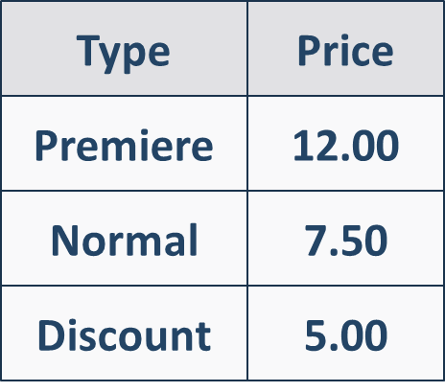

string movieType = Console.ReadLine();

int rows = int.Parse(Console.ReadLine());

int seatsPerRow = int.Parse(Console.ReadLine());

int totalSeats = rows * seatsPerRow;

double pricePerSeat = 0;

if (movieType == "Premiere")

{

pricePerSeat = 12.00;

}

else if (movieType == "Normal")

{

pricePerSeat = 7.50;

}

else if (movieType == "Discount")

{

pricePerSeat = 5.00;

}

else

{

Console.WriteLine("Invalid movie type");

return;

}

double totalPrice = totalSeats * pricePerSeat;

Console.WriteLine($"Total price: {totalPrice:F2}");

### Example

|  |  |  |
| --- | --- | --- |
| **Input** | **Output** | **Comments** |
| Normal  12  9 | 810.00 | Type of the movie is Normaland the price for one seat is: 7.50  Total count of the seats in the cinema: 12 * 9 = 108  Total price for all seats: 108 * 7.50 = 810.00 |
| Premiere  10  5 | 600.00 | Type of the movie is Premiereand the price for one seat is: 12.00  Total count of the seats in the cinema: 10 * 5 = 50  Total price for all seats: 50 * 12.00 = 600.00 |
| Discount  10  5 | 250.00 | Type of the movie is Discountand the price for one seat is: 5.00  Total count of the seats in the cinema: 10 * 5 = 50  Total price for all seats: 50 * 5.00 = 250.00 |